“Prophetic Witness and Hope in Difficult Times”
College Park Quarterly Meeting will be hosted by Redwood Forest Friends Meeting and Friends House on Saturday, January 19, 2019, at Family Bible Church, 697 Benicia Dr, Santa Rosa, CA 95409.

Registration: On-site registration from 7:45am-8:30 am. Requested contributions: $35 for adults, $10 for 5-24 year-olds, free for children under 5. Checks payable to "College Park Quarterly Meeting" (spelled out). These amounts include snacks and lunch but not supper. A limited number of evening meals can be arranged for those who pre-pay at registration. At time of registration, Friends will be asked whether they will be attending worship-sharing.

Children and Teens: There will be concurrent children and teen programs. Permission forms are on the CPQM website, http://collegeparkquarterlymeeting.org/ Teens will be engaged in activities off site, so forms completed by parents/guardians will be essential to guarantee their ability to participate.

Schedule:
7:45 am Registration and Breakfast Snacks
8:30-9 Family Worship
9:00 Welcoming Plenary
9:30-10:15 Opening Plenary for Business
10:30-11:45 Worship Sharing (at Church and Friends House)
11:45-1:00 Lunch
1:00-2:15 Worship and Keynote with Brent Bill (see bio and information below)
2:30-4:00 Interest Groups
4:15-5:00 Closing Plenary for Business
5:00-5:30 Closing Worship
6:00 Simple Supper at RFFM Meetinghouse
Note: There is a concurrent Women’s March in downtown Santa Rosa from 10am-2pm. Our schedule is arranged so that Friends who wish to participate in the first two hours of that event can leave Quarterly Meeting after the welcoming plenary and return for lunch. This would mean missing worhip-sharing.

Supper: Teens will be preparing a simple vegetarian meal at the Redwood Forest Friends Meetinghouse at 6pm for those Friends who would like to stay for more fellowship. Tickets to this meal will be available for purchase at the time of registration, and the supply will be limited since the Meetinghouse capacity is limited.

Overnight Hospitality: Friends who need overnight hospitality in Santa Rosa should contact Betz Miller betzmiller@comcast.net

Live Streaming: If you can’t attend in person, videostreaming of the keynote speaker will be available. Individuals or small groups who would like to attend remotely, please contact Eric Sabelman at eesabelman@gmail.com or 650-322-2455

Interest Groups:
- FCL/CA: Representing our Quaker presence in Sacramento, Kevan Insko will talk about bills that are in the works, the state budget, and how to get involved in advocacy.
- Corporate Witness: What are some of the ways our Meetings engage in public witness? How do we decide whether to conduct vigils, participate in marches, organize other non-violent action, or host public meetings for worship? Are there other forms in which Meetings are undertaking direct action? With keynote speaker Brent Bill and Ministry and Oversight Committee.
- Friends House: Join Mico Sorrel and others to learn more about Friends House -- history, Quaker connections, community life, aspirations and whatever else is on your mind. Our time together will also include a tour with staff member Jet Howell. You need not be considering moving to Friends House to benefit from and enjoy this interest group.

J. Brent Bill will be speaking in Santa Rosa:
Brent is a writer, photographer, retreat leader, writing coach, and Quaker minister. He has written and co- written many books including:
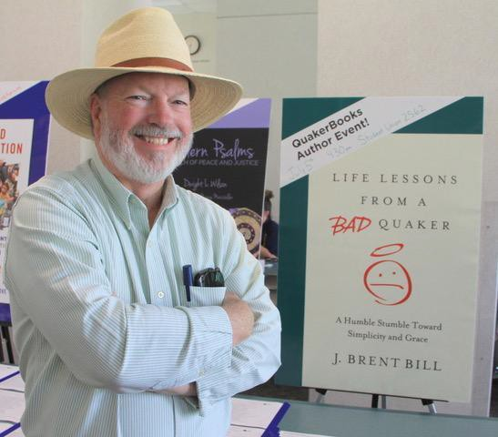
- Holy Silence: 2nd Edition, Revised and Expanded
- Life Lessons from a Bad Quaker: A Humble Stumble Toward Simplicity and Grace
- Finding God in the Verbs: Crafting a Fresh Language of Prayer
- Awaken Your Senses: Exercises for Exploring the Wonder of God
- Sacred Compass: The Way of Spiritual Discernment
- Imagination and Spirit: A Contemporary Quaker Reader

… in addition to more than 100 short stories and non-fiction articles.
He graduated from Wilmington College and the Earlham School of Religion. He has worked as a local Friends meeting pastor, the vice-president of the Indianapolis Center for Congregations, a faculty member at Earlham School of Religion, and go-cart track operator. He is on the faculty of the MidWest Writers Workshop and the Indiana Writers Center.
Most recently, he retired as Associate Secretary of Communications, Publications, and Outreach for Friends General Conference. He has served Friends on a number of boards and as a volunteer, including various yearly meeting committees, Friends United
Meeting’s publication commission, and Friends World Committee for Consultation. He is currently on the board of Quaker Voluntary Service.
Brent lives on Ploughshares Farm, which is fifty acres of Indiana farmland that is being reclaimed for native hardwood forests and warm season prairie grasses.
If you’d like to get know Brent a little, check out the PBS special “Festival of Friends.” “Festival of Friends” presents four nationally-known artists—singer/songwriter Carrie Newcomer, and authors J. Brent Bill, Philip Gulley, and Scott Russell Sanders for a delightful hour of story, song, essay, and humor, inspired by the rich Quaker tradition of finding the wondrous and sacred within the ordinary and everyday. This program was made possible with the support of Earlham College. https://video.wfyi.org/video/wfyi- arts-programs-festival-friends/

Here’s Brent’s Santa Rosa speaking schedule:
College Park Quarterly Meeting on January 19, 2019 at 1 pm
"Prophetic Witness and Hope in Difficult Times" – Together we will examine how to speak faithfully and truthfully in dangerous times to the values our Friendly faith holds dear. We'll explore how early Friends spoke to their times, what lessons we can take from them, how we know (individually and corporately) what work is ours to do, and how we can present our witness positively. We’ll
discuss how can we be for instead of against (for peace, for equality, etc), thereby sustaining a witness based in deep faith that supersedes administrations/governments and offers a winsome invitation for others to join us.

Redwood Forest Friends Meeting on January 20 at noon
“Staying a Vital Meeting: Learning from Others” –Brent served many years as a congregational consultant and then as coordinator of FGC’s “New Meetings Project.” He was also a member of the Society for the Scientific Study of Religion and the Religious Research Association. As such, he’s learned a thing or three about what makes for congregational vitality. He’ll share some of
what he’s learned and how it applies to Friends meetings. There will also be a time for questions and (hopefully) some answers.
Friends House on January 22 at 7:15pm
“Friendly Fun” – Quaker faith is to be taken seriously, but not always in dead earnest. So we’ll have a laugh or two as we take a Quaker trivia test, share some Quaker jokes and riddles, and look at Quaker products (bad and good) through the years. After all, a little levity never hurt anybody – well, except for that one Friend.

